**Hamilton Family Research Report  
(Hamilton - Haley - Zink)**

Tracing the Hamilton line from Greene County, Pennsylvania and Wetzel County, West Virginia  
to Tacoma, Washington

*Prepared for: Brent Hamilton Haley  
Date: January 09, 2026*

# 1. Executive Summary

**Direct Hamilton ancestor line (current best-supported chain):**

* Brent Hamilton Haley (living).
* David Hamilton Haley (10 Jun 1943 - 2015).
* Frank Hamilton Haley (18 Jun 1911 - 13 Oct 1981) m. Nellie LaBelle Zink (28 Oct 1905 - 18 Aug 1997*).
* Margaret Mae Hamilton (1882 - 1977) m. James Clifford “J.C.” Haley (1884 - 1954).
* Thomas Benson “T.B.” Hamilton (17 May 1858 - 28 Sep 1905) m. Sarah Elizabeth Woodruff (1860 - 1957).
* Hiram Hamilton (Feb 1825 - 1901) m. Elizabeth Hostutler.
* William Hamilton (~1795 - 3 Apr 1879) m. Margaret “Maple/Mapel” Hamilton (1806 - 29 Oct 1869).

**Key corrections from family oral history (Janet (Haley) Fesq):**

* Janet is the older sibling of David; David is a twin with Jonathan.
* Nellie LaBelle Zink is a Zink by birth (Nova Scotia) and married into the Haley/Hamilton line through Frank Hamilton Haley.

* Nellie’s death date is currently sourced from a Social Security death-index summary and should be confirmed with a Washington death record or obituary.

# 2. Scope and Approach

This report focuses on the Hamilton lineage (with key spouse lines) and compiles evidence from: (a) the documents you provided (Hamilton–Haley lineage narrative, EQT lease packet, tax map, and aerial parcel map); (b) family oral history provided by Janet (Haley) Fesq; and (c) selected public genealogy references and cemetery records. Where a claim rests on compiled/secondary sources, the report flags it and lists the best primary records to confirm.

# 3. Evidence Snapshot (what is well-supported vs. needs confirmation)

|  |  |  |  |
| --- | --- | --- | --- |
| Person / Relationship | What we have | Confidence | Best next record(s) to confirm |
| T.B. Hamilton (1858–1905) and role in Hundred, WV | Family lineage document; EQT lease packet ties mineral interest to T.B.; Find a Grave memorial. | High | Wetzel Co. deeds; probate/estate; local histories |
| Margaret Mae Hamilton is daughter of T.B.; moved to Tacoma in 1907 with J.C. Haley | Family lineage doc + Janet Fesq oral history. | High–Medium | WV marriage record; WA census/dir; WA marriage index |
| Frank Hamilton Haley is son of Margaret Mae Hamilton & J.C. Haley | Janet Fesq oral history + Frank’s Find a Grave memorial. | High | Birth certificate; 1930/1940 census; WA birth index |
| Nellie LaBelle Zink is spouse of Frank; Nova Scotia origins | Janet Fesq oral history + Zink and Mossman/Zinck memorials; SS death-index summary for Nellie. | Medium | Nova Scotia birth record; Pierce Co. marriage certificate; WA obituary/death record |
| Older generations: Hiram → William Hamilton (Greene Co., PA) | County-history excerpt + Find a Grave entries; some compiled trees. | Medium | Greene Co. probate; land deeds; census |

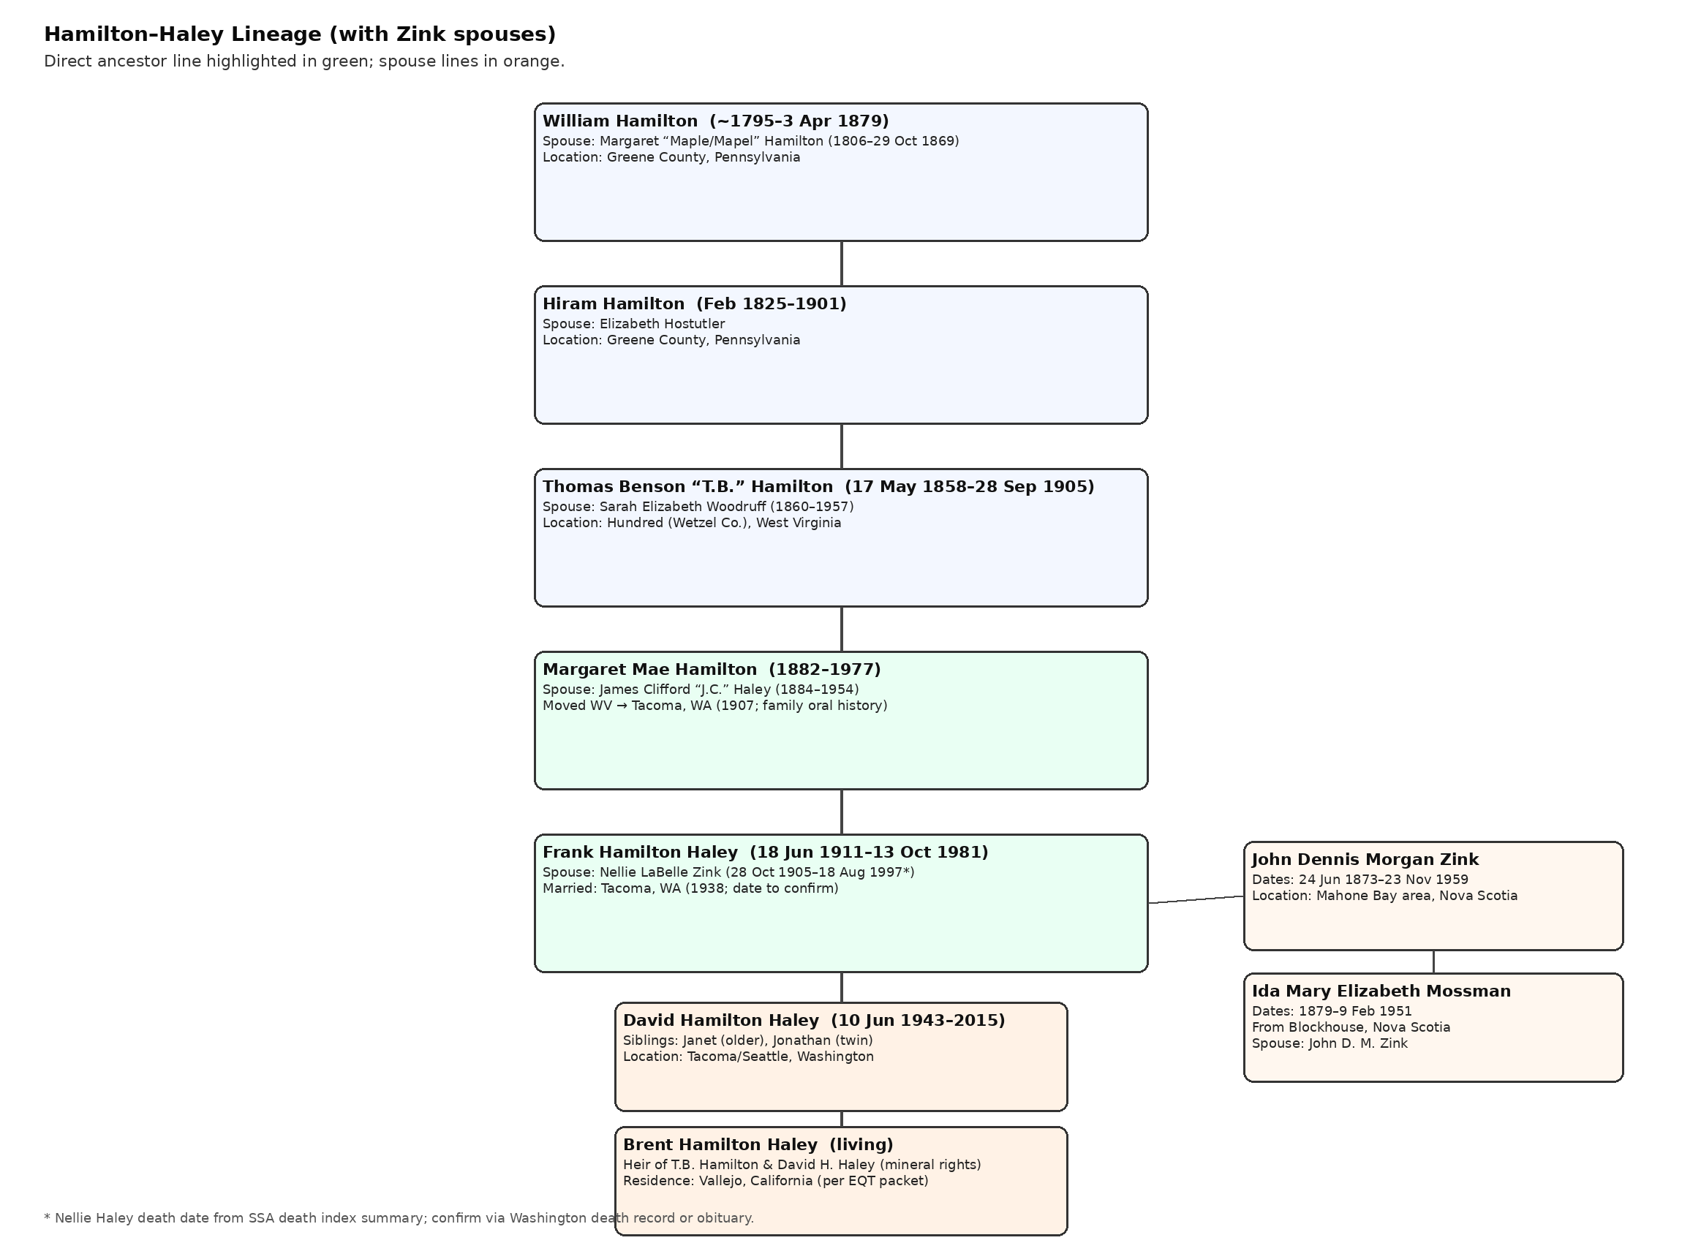

Figure 4.1. Hamilton → Haley direct line with Nellie Zink’s parents (spouse line).

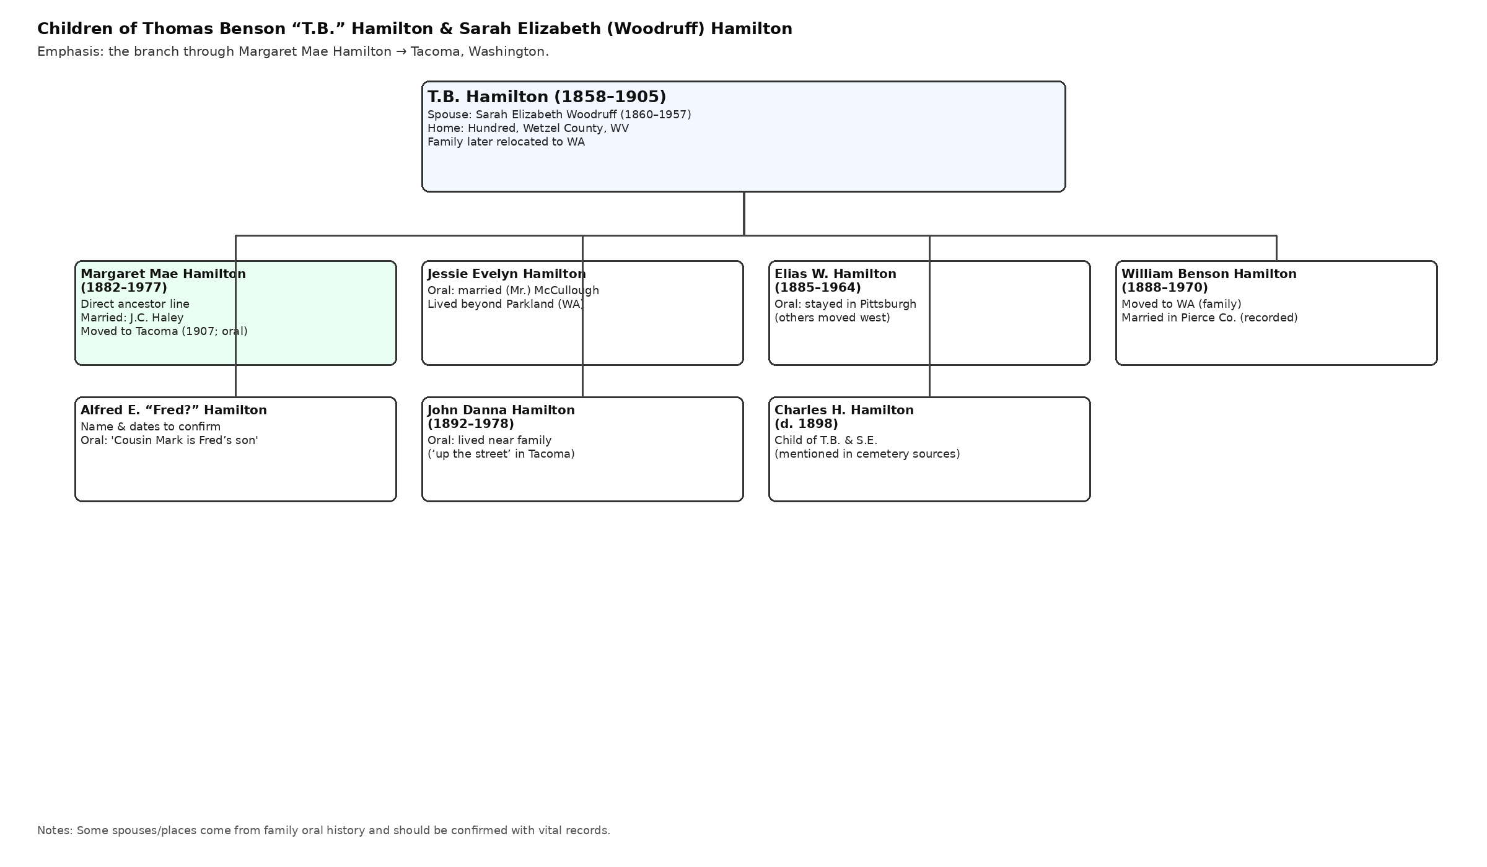

Figure 4.2. Children of T.B. Hamilton & Sarah Woodruff (with oral-history notes).

# 4. Narrative Lineage and Migration Story

## 4.1 Greene County, Pennsylvania roots (pre-1858)

The earliest currently named Hamilton couple in this line is William Hamilton and his wife Margaret (“Maple/Mapel”). A Greene County history excerpt reports Margaret’s death date (29 Oct 1869) and William’s death date (3 Apr 1879), supporting the existence of the William–Margaret couple in Greene County, Pennsylvania.

Their son appears to be Hiram Hamilton (born Feb 1825, Greene County, Pennsylvania) who married Elizabeth Hostutler. A Greene Connections museum catalog entry identifies Elizabeth (Hostutler) Hamilton as Hiram’s wife.

## 4.2 T.B. Hamilton in Hundred, Wetzel County, West Virginia (1858–1905)

Thomas Benson “T.B.” Hamilton was born in 1858 and died in 1905. The provided Hamilton–Haley lineage document describes him as a prominent early landowner associated with the development of Hundred, Wetzel County, West Virginia, and states he married Sarah Elizabeth Woodruff in 1881.

The EQT lease packet for mineral rights in Hundred explicitly states that T.B. Hamilton owned 25% of the oil and gas rights under a 0.63125-acre lot in Hundred, WV, and that the interest passed down through the Hamilton–Haley line.

## 4.3 Westward migration to Tacoma, Washington (1907 and after)

Per Janet (Haley) Fesq’s oral history, Margaret Mae Hamilton (the oldest child of T.B.) married J.C. Haley in West Virginia and moved west to Tacoma in 1907 because J.C.’s asthma required a different climate. Several of Margaret’s siblings followed to Washington; oral history notes that Elias stayed in Pittsburgh while others relocated near the Tacoma/Parkland area.

## 4.4 Frank Hamilton Haley and the Zink connection (Nova Scotia → Tacoma)

Frank Hamilton Haley, son of Margaret Mae Hamilton and J.C. Haley, married Nellie LaBelle Zink. Nellie was born in 1905 in Mahone Bay, Nova Scotia, and was one of 10 children of John Dennis Morgan Zink and Ida Mary Elizabeth (Mossman) Zink, with Ida originally from Blockhouse, Nova Scotia.

## 4.5 David Hamilton Haley and descendants

David Hamilton Haley (born 10 Jun 1943) had an older sister Janet (Haley) Fesq and a twin brother Jonathan. David’s child Brent Hamilton Haley is the current-generation heir identified in the EQT materials.

# 5. Family Group Sheets (couple-by-couple profiles)

## 5.1 William Hamilton & Margaret “Maple/Mapel” Hamilton (Greene County, PA)

* Husband: William Hamilton (~1795 – 3 Apr 1879).
* Wife: Margaret “Maple/Mapel” Hamilton (1806 – 29 Oct 1869).
* Known location: Greene County, Pennsylvania.
* Known/likely child: Hiram Hamilton (born Feb 1825).

**Notes:**

* The William–Margaret relationship and death dates are supported by a Greene County history excerpt and Find a Grave memorials; parentage beyond William is not yet established here.

## 5.2 Hiram Hamilton & Elizabeth Hostutler (Greene County, PA)

* Husband: Hiram Hamilton (Feb 1825 – 1901).
* Wife: Elizabeth Hostutler (dates not yet confirmed).
* Known location: Greene County, Pennsylvania.
* Probable child: Thomas Benson “T.B.” Hamilton (born 1858).

**Notes:**

* A Greene Connections museum-catalog entry identifies Elizabeth (Hostutler) Hamilton as Hiram’s wife.
* A direct primary record naming T.B.’s parents (e.g., death certificate, marriage record, probate) would raise confidence to high.

## 5.3 Thomas Benson “T.B.” Hamilton & Sarah Elizabeth Woodruff (Hundred, WV)

* Husband: Thomas Benson “T.B.” Hamilton (17 May 1858 – 28 Sep 1905).
* Wife: Sarah Elizabeth Woodruff Hamilton (1860 – 1957).
* Married: 1881 (location not yet confirmed in a primary record in this packet).
* Known location: Hundred, Wetzel County, West Virginia; later family relocation to Washington.

**Notes:**

* EQT lease materials state: T.B. Hamilton held 25% mineral interest under a 0.63125-acre lot in Hundred.
* Children list includes Margaret Mae, Jessie Evelyn, Elias W., William Benson, Alfred E., John Danna; at least one additional child (Charles H.) is suggested by cemetery sources.

## 5.4 Margaret Mae Hamilton & James Clifford “J.C.” Haley

* Wife: Margaret Mae Hamilton (1882 – 1977), oldest child of T.B. Hamilton.
* Husband: James Clifford “J.C.” Haley (1884 – 1954).
* Married: West Virginia (per family oral history; record not yet attached).
* Moved: to Tacoma, Washington in 1907 (per family oral history).
* Known child in this line: Frank Hamilton Haley (1911–1981).

**Notes:**

* Oral history indicates the move was prompted by asthma/health concerns and that multiple Hamilton siblings later followed west.

## 5.5 Frank Hamilton Haley & Nellie LaBelle Zink

* Husband: Frank Hamilton Haley (18 Jun 1911 – 13 Oct 1981).
* Wife: Nellie LaBelle Zink (28 Oct 1905 – 18 Aug 1997*).
* Married: Tacoma, Washington (1938; exact date to confirm).
* Children: Janet (older), David Hamilton (twin), Jonathan (twin).

**Notes:**

* Nellie’s parents: John Dennis Morgan Zink and Ida Mary Elizabeth Mossman (Blockhouse, Nova Scotia).
* * Nellie death date currently from a Social Security death-index summary; confirm with a Washington record.

## 5.6 David Hamilton Haley → Brent Hamilton Haley

* David Hamilton Haley (10 Jun 1943 – 2015). Siblings: Janet (older), Jonathan (twin).
* Child: Brent Hamilton Haley (living).

**Notes:**

* EQT lease packet identifies Brent as an heir of T.B. Hamilton and David Hamilton Haley and connects the family to mineral rights in Hundred, WV.

# 6. Zink Family Extension (Nellie LaBelle Zink’s known ancestors)

This section extends the tree through Nellie’s line (spouse line), based on oral history and public-record summaries.

|  |  |  |
| --- | --- | --- |
| Person | Known details | Best next record(s) |
| Nellie LaBelle Zink | Born 28 Oct 1905, Mahone Bay, Nova Scotia; later lived in Tacoma, WA; married Frank Hamilton Haley. | Nova Scotia birth record; Pierce County marriage certificate |
| John Dennis Morgan Zink | Dates: 24 Jun 1873 – 23 Nov 1959; associated with Mahone Bay area, Nova Scotia. | Nova Scotia vital records; cemetery/burial record; obituary |
| Ida Mary Elizabeth Mossman | Dates: 1879 – 9 Feb 1951; from Blockhouse, Nova Scotia; daughter of Isaac & Rebecca Mossman (per obituary transcription). | Nova Scotia marriage record; birth/baptism record; Mossman family records |

Oral history note: Nellie was one of ten children of John and Ida; names of the other children are not yet documented in the provided materials.

# 7. Hundred, WV mineral-rights evidence (EQT packet)

The EQT materials describe a 0.63125-acre lot in the town of Hundred, Wetzel County, West Virginia (Tax Map 06-2-80; Deed Book 33, Page 68). The letter states that Thomas Benson “T.B.” Hamilton owned 25% of the oil and gas rights under this lot and that the interest descended to Brent via David Hamilton Haley.

**Key identifying details (from the lease packet):**

* Town: Hundred, Wetzel County, West Virginia.
* Parcel size: 0.63125 acres.
* Tax Map: 06-2-80.
* Deed reference: Deed Book 33, Page 68.
* Title note: conveyed to Brent Hamilton Haley by David Hamilton Haley by intestate succession (as stated in the Memorandum of Oil and Gas Lease).

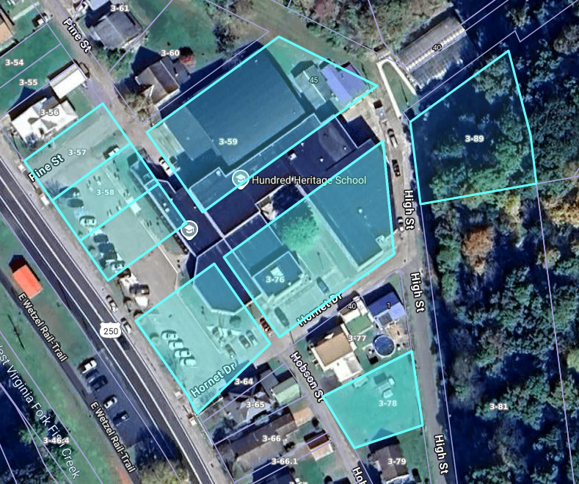

Appendix A - Figure A1. Digitized aerial with parcel outlines (provided file).

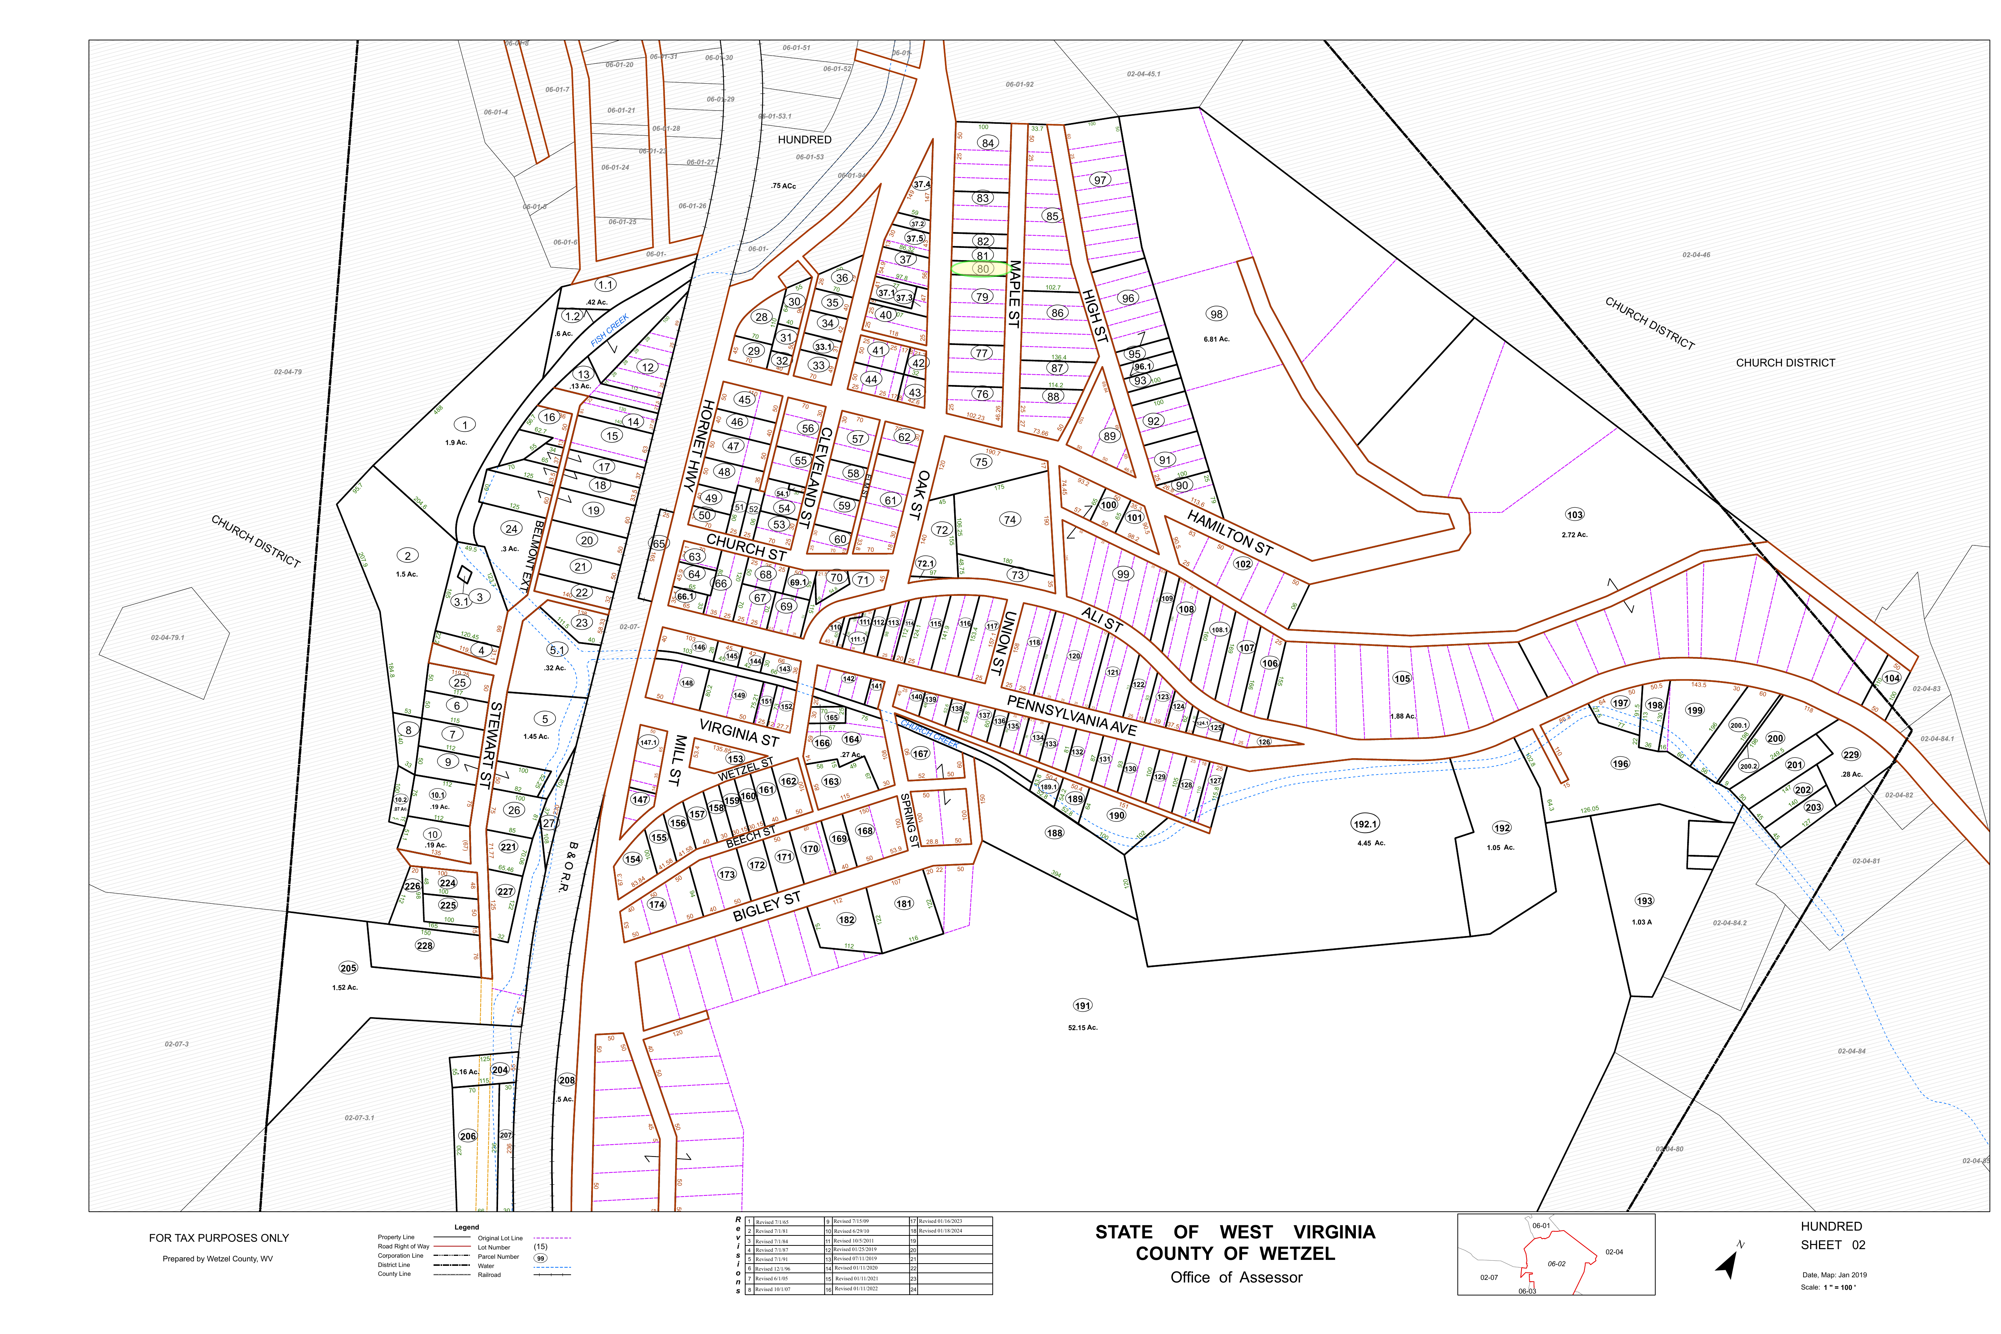

Appendix A - Figure A2. Wetzel County assessor tax map (Hundred, Sheet 02; provided PDF).

# References

**[1]** Provided document: Hamilton–Haley Family Lineage.docx (client-provided compilation; accessed Jan 2026).

**[2]** Provided document: BHaley OGL Wetzel WV.pdf (EQT/Honor Resources lease packet; accessed Jan 2026).

**[3]** Provided document: Tax Map 06-0002.pdf (Wetzel County assessor map; accessed Jan 2026).

**[4]** Provided image: Dig Aerial with Parcels.png (client-provided; accessed Jan 2026).

**[5]** Oral history: Personal communication from Janet (Haley) Fesq, relayed by the client (Jan 2026).

**[6]** Find a Grave: Thomas Benson Hamilton memorial (https://www.findagrave.com/memorial/46255181/thomas_benson-hamilton).

**[7]** Find a Grave: Frank Hamilton Haley memorial (https://www.findagrave.com/memorial/156713758/frank_hamilton-haley).

**[8]** Find a Grave: J. Dennis M. Zink memorial (https://www.findagrave.com/memorial/157469159/j-dennis_m-zink).

**[9]** Find a Grave: Ida Mary Elizabeth (Mossman) Zinck memorial (https://www.findagrave.com/memorial/65937210/ida_mary-elizabeth-zinck).

**[10]** Greene Connections museum catalog: Elizabeth (Hostutler) Hamilton tintype entry (https://hub.catalogit.app/greene-connections/folder/entry/8fae3180-63bd-11ed-b38d-450b103e8a4b).

**[11]** Greene County local history excerpt: Hamilton history excerpt referencing William and Margaret (Maple) Hamilton (https://www.ourfamilyhistories.com/hsdurbin/greene/hamil.html).

**[12]** SSA death-index summary: Summary entry for Nellie L. Haley (born 28 Oct 1905; died 18 Aug 1997) as reflected in a public index (https://sortedbyname.com/letter_h/haley/index_397.html).

**[13]** Nova Scotia Archives: Vital Statistics search portal (https://archives.novascotia.ca/vital-statistics/).